MCS Lab 1 Report

Sakka Mohamad-Mario
el-ghoul Layla
mahmoud mirghani abdelrahman
MCS

1. Plots resulting from code

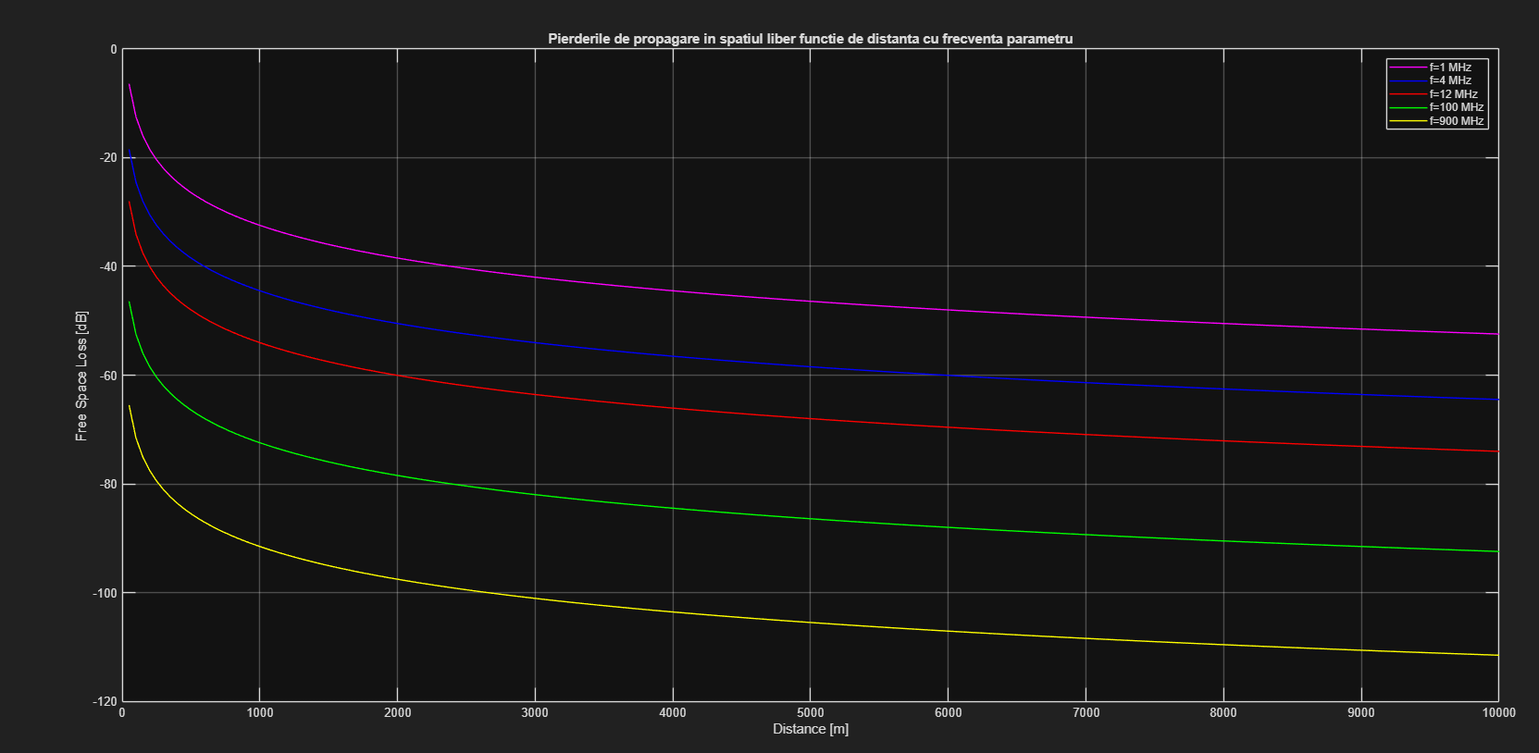
Figure 1: Plot of free space propagation loss as a function of distance with frequency as a parameter
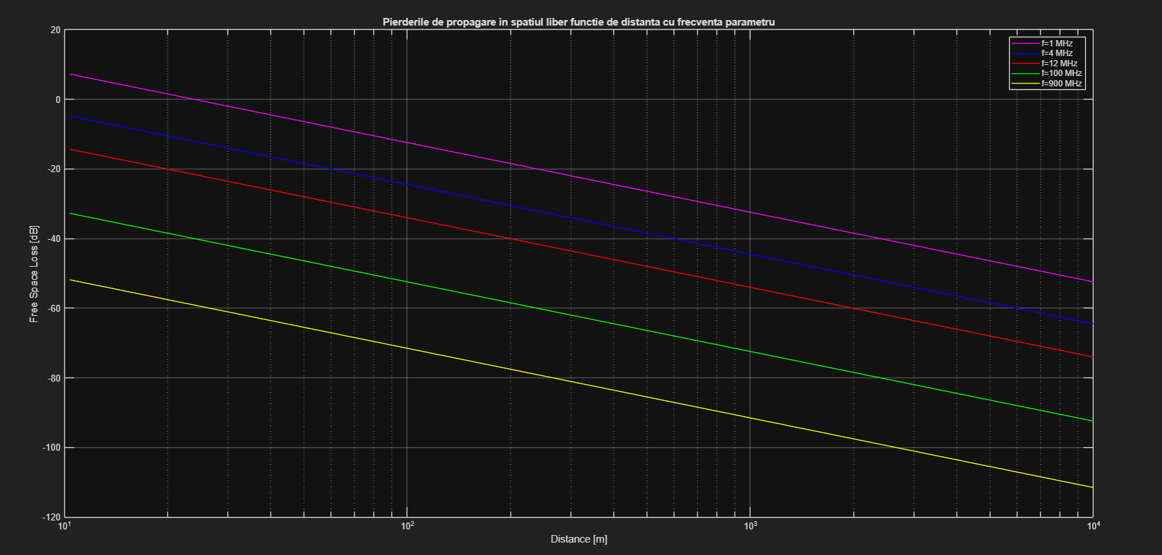
Figure 2: Plot of free space propagation loss as a function of distance with frequency as a parameter, using a logarithmic scale for distance.
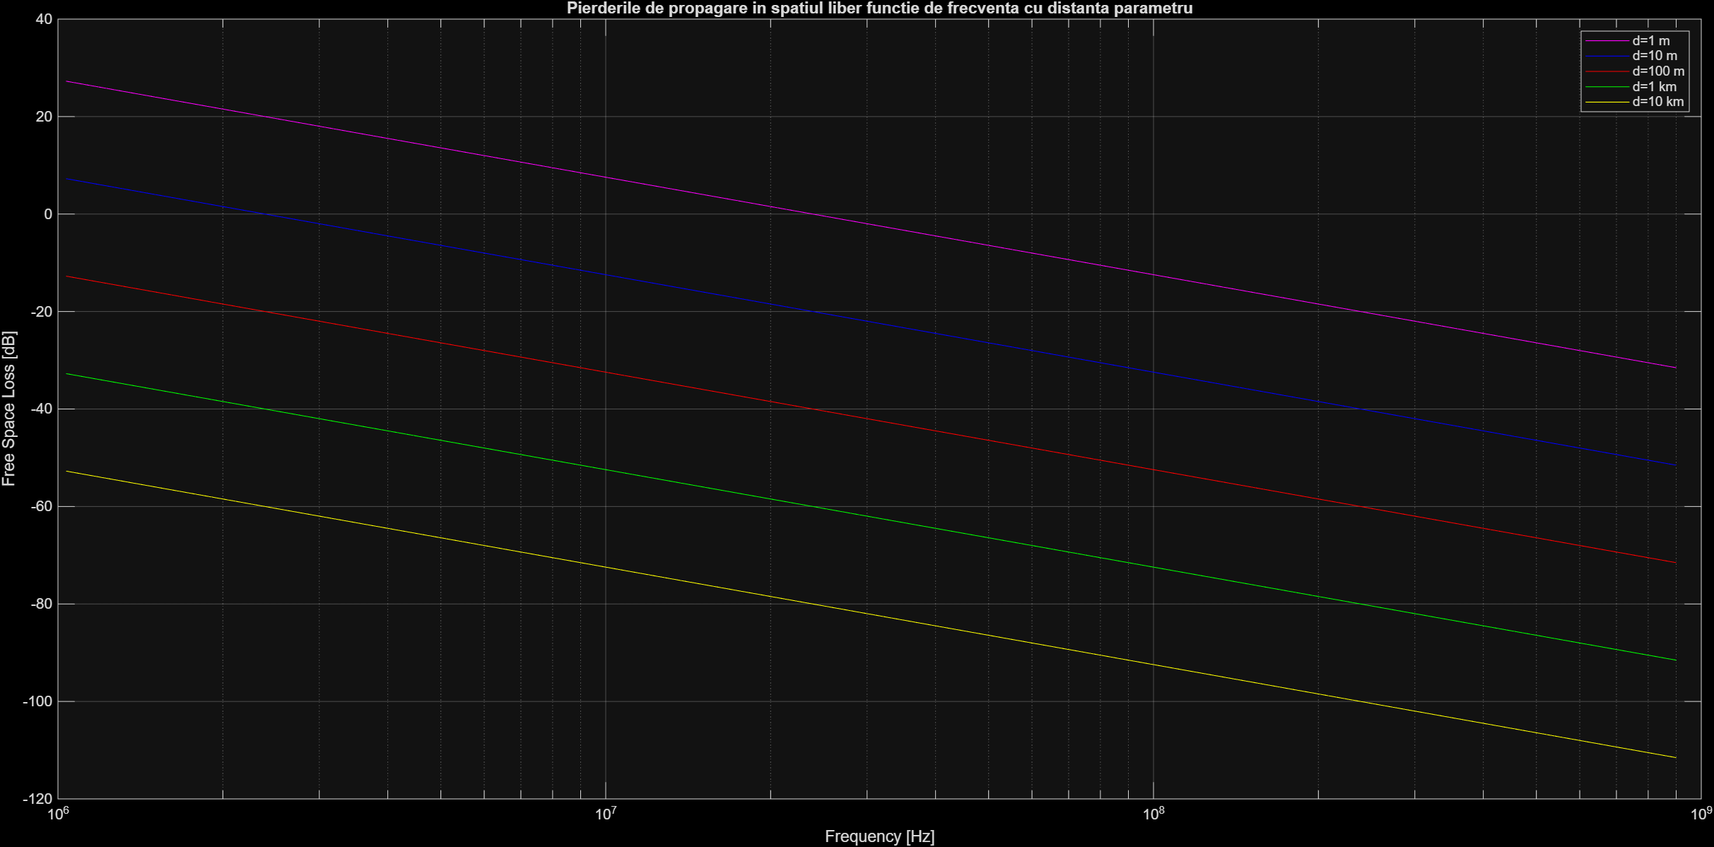
Figure 3: Plot of free space propagation loss as a function of frequency with distance as a parameter, using a logarithmic scale for frequency.

2. Answering questions

Q1.

